Operations Processes

OP Category | MOC |  | Operation Process
Execution Mngt |  | Production |  | Create/Modify/Delete Production Order from business
 |  | Production |  | Create/Modify/Delete Production Order from Shop Floor
 |  | Packaging |  | Create/Modify/Delete Packaging order from business
 |  | Inventory |  | Create/Modify/Delete Transfer Order from Business
 |  | Inventory |  | Create/Modify/Delete Transfer Order from Shop Floor
 |  | Production |  | Execute Production Order
 |  | Inventory |  | Execute Transfer Order
 |  | Quality |  | QC – Product quality management
 |  | Quality |  | QA – product release
Resource Mngt |  |  |  | Publish Equipment Failure Report per period
Global Operation Mngt
 |  |  |  | Publish shift/daily/Monthly/Yearly Production Report
 |  |  |  | Publish period utility report
 |  |  |  | Publish average yield per product/period
Master Data Def./Sync |  |  |  | Create/Modify/Delete Product Definition
 |  |  |  | Create/Modify/Delete Quality Control Plan
 |  |  |  | Create/Modify/Delete Quality Test definition
 |  |  |  | Create/Modify/Delete Work Segment
 |  |  |  | Create/Modify/Delete Equipment Class
 |  |  |  | Create/Modify/Delete Equipment
 |  |  |  | Create/Modify/Delete Personnel Class
 |  |  |  | Create/Modify/Delete Person
 |  |  |  | Create/Modify/Delete Material Class
 |  |  |  | Create/Modify/Delete Material Definition
 |  |  |  | Create/Modify/Delete

Business process description

Example 1 : Create Production Order

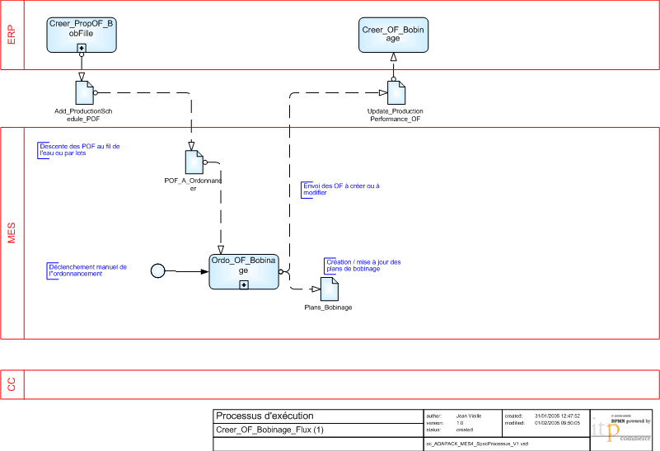
Exemple 2 : Collect operations execution data

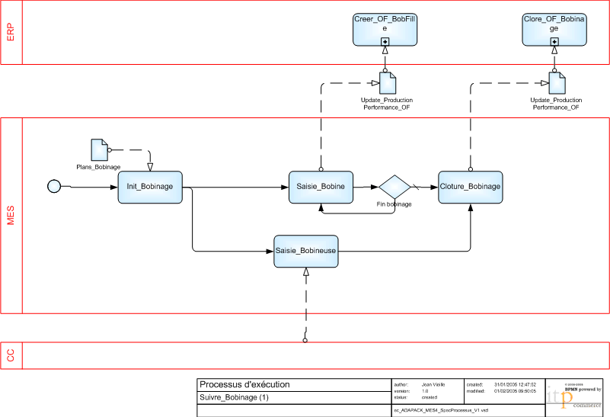

Task list

Generic Activity
Task
Scheduling
Generate detail production schedule

Generate detail packaging schedule

Generate detail picking schedule

Dispatching
Create / modify Work Unit dispatch list

Execution
Print label

Check material input

Material reconciliation

Resource management
Update equipment status

Release material lot

Update personnel availability

Definition management

Data Collection

Tracking

Analysis

